Write R program to find the following Regressions with the sample data and visualize the regressions graphically.
- Linear Regression

Program:
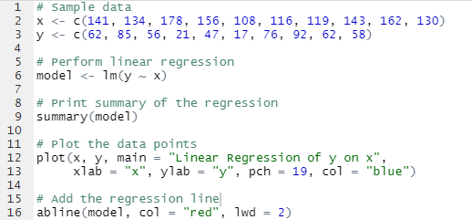
Output:
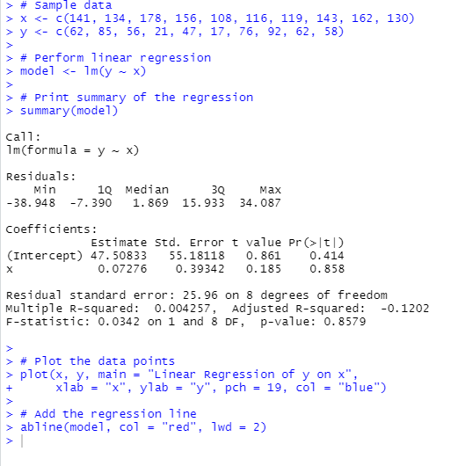
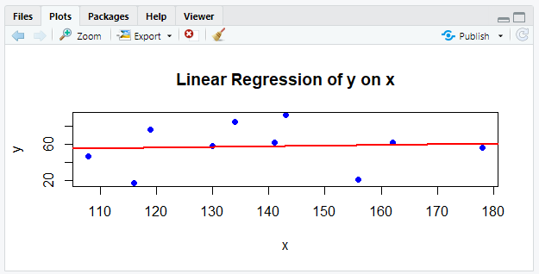
Explanation:

x <- c(141, 134, 178, 156, 108, 116, 119, 143, 162, 130)
- This line creates a numeric vector x, containing the sample data points for the independent variable (predictor).
y <- c(62, 85, 56, 21, 47, 17, 76, 92, 62, 58)
- This line creates another numeric vector y, which holds the corresponding values of the dependent variable (response).
model <- lm(y ~ x)
- This line fits a linear regression model where y is modeled as a function of x.
- lm() stands for "linear model".
- The syntax y ~ x means "predict y using x".
- The result is stored in the object model.
summary(model)
- This line prints a detailed summary of the linear regression model.
- It shows important statistics like coefficients (slope and intercept), R-squared, p-values, residuals, etc.
- Useful for understanding how well the model fits the data.
plot(x, y, main = "Linear Regression of y on x",
xlab = "x", ylab = "y", pch = 19, col = "blue")
- This creates a scatter plot of the data points.
- x and y are plotted on the horizontal and vertical axes, respectively.
- main sets the title of the plot.
- xlab and ylab label the x and y axes.
- pch = 19 sets the plot character to filled circles (better visibility).
- col = "blue" colors the points blue.
abline(model, col = "red", lwd = 2)
- This adds the regression line to the plot.
- abline() draws a straight line; here it uses the intercept and slope from model.
- col = "red" colors the regression line red.
- lwd = 2 sets the line width to 2, making it thicker and easier to see.

- Multiple Regression

Program:
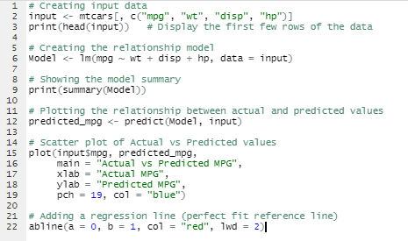
Output:
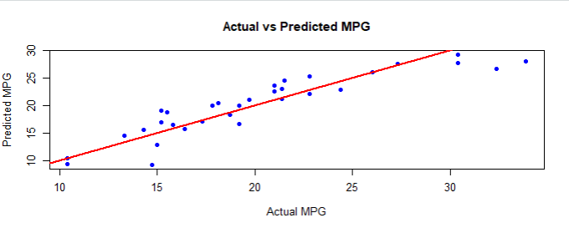
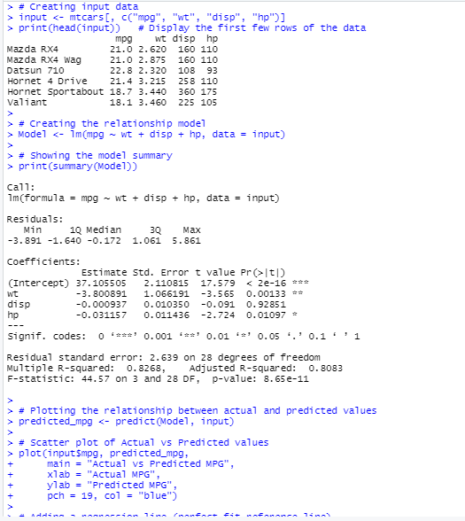
Explanation:
#Creating input data.
input <- mtcars[,c("mpg","wt","disp","hp")]
- This line extracts specific columns from the built-in dataset mtcars.
- mtcars[, c("mpg","wt","disp","hp")] selects only the columns "mpg", "wt", "disp", and "hp".
- The result is assigned to a new data frame called input.
- So, input now contains only those four variables from the mtcars dataset.
print(head(input))
- head(input) returns the first 6 rows of the input data frame.
- print() outputs these rows to the console.
- This lets you quickly check the first few data points in input.
Model <- lm(mpg ~ wt + disp + hp, data = input)
Now you’re checking how well your model predicts the actual values of mpg (miles per gallon).
The goal of this section is to compare the predicted vs actual values of mpg visually.
predicted_mpg <- predict(Model, input)

What it does:
- predict() is an R function that takes a model (like lm) and a dataset, and computes the predicted values of the dependent variable based on the model equation.
- Here, it uses your trained regression model (Model) to predict the mpg for all cars in the input dataset.
plot(input$mpg, predicted_mpg,
main = "Actual vs Predicted MPG",
xlab = "Actual MPG",
ylab = "Predicted MPG",
pch = 19, col = "blue")

What it does:
This line creates a scatter plot comparing:
- x-axis (input$mpg) → actual observed values of mpg
- y-axis (predicted_mpg) → model-predicted values of mpg

Purpose:
- It helps you visually assess how well the model fits.
- If the model predictions are accurate, most points should lie close to a straight line (the 45° line where predicted = actual).

Parameter details:
- main = "Actual vs Predicted MPG" → Sets the title of the graph.
- xlab = "Actual MPG" → Label for the x-axis.
- ylab = "Predicted MPG" → Label for the y-axis.
- pch = 19 → Defines the plotting character.
19 gives solid circular points.
- col = "blue" → Makes all the points blue in color.
So this line plots a blue dot for each car, where the x-position is the actual mpg and the y-position is the predicted mpg.

abline(a = 0, b = 1, col = "red", lwd = 2)

What it does:
This adds a reference line to your scatter plot.
- abline() adds a straight line to an existing plot.
- Here, you specify:
  - a = 0 → the intercept of the line
intercept = 5.
That’s the point where the line cuts the y-axis (at y = 5).
  - b = 1 → the slope of the line
Slope = 2 -> This means: for every 1 unit increase in x, y increases by 2 units.
Slope = 2 -> This means: for every 1 unit increase in x, y decreases by 2 units.
So the line drawn is the equation:
[
y = x
]
This is a perfect fit line — if the model were perfect, every predicted value would equal the actual value, and all blue points would lie exactly on this red line.

Parameter details:
- col = "red" → makes the line red.
- lwd = 2 → increases the line width for better visibility.

Interpretation:
- Points on the red line → predicted ≈ actual → good prediction.
- Points above the line → model underestimated the mpg (predicted < actual).
- Points below the line → model overestimated the mpg (predicted > actual).

- Logistic Regression
Program:
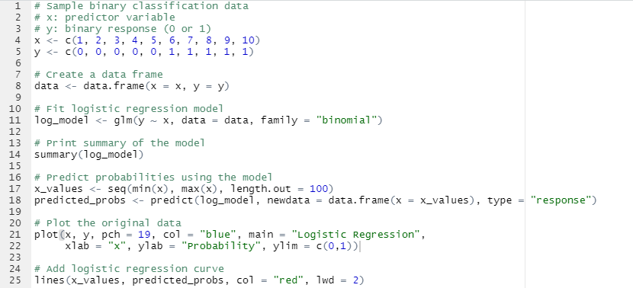

Output:

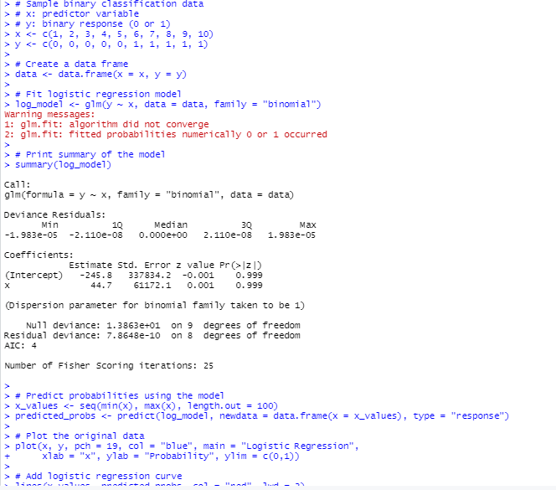
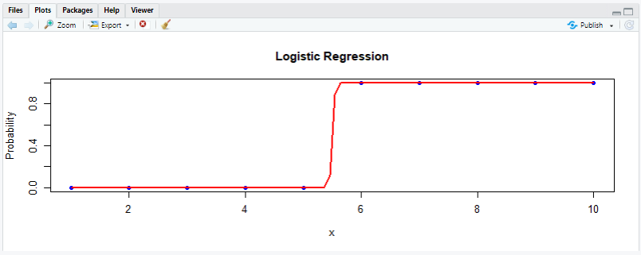
Explanation:
# Sample binary classification data
# x: predictor variable
# y: binary response (0 or 1)
x <- c(1, 2, 3, 4, 5, 6, 7, 8, 9, 10)
- Creates a numeric vector x representing the predictor (independent variable) with values from 1 to 10.
y <- c(0, 0, 0, 0, 0, 1, 1, 1, 1, 1)
- Creates a numeric vector y representing the binary response variable with values 0 or 1, where the first five are 0 and the last five are 1.
# Create a data frame
data <- data.frame(x = x, y = y)
- Combines vectors x and y into a data frame named data. This structure is easier to work with in modeling functions. A data frame in R is a table or a two-dimensional array-like structure in which each column contains values of one variable and each row contains one set of values from each column. Data frames are used as the fundamental data structure by most of R's modeling software.
# Fit logistic regression model
log_model <- glm(y ~ x, data = data, family = "binomial")
- Fits a logistic regression model predicting y using x.
- glm() is the function for generalized linear models.
- family = "binomial" specifies logistic regression (for binary outcomes).
- The fitted model is stored in the variable log_model.
# Print summary of the model
summary(log_model)
- Prints a detailed summary of the logistic regression model.
- This includes coefficients, standard errors, z-values, p-values, and overall model fit statistics.
# Predict probabilities using the model
x_values <- seq(min(x), max(x), length.out = 100)
- Creates a sequence x_values from the minimum to maximum of x, divided into 100 evenly spaced points.
- This is for plotting a smooth logistic curve.
predicted_probs <- predict(log_model, newdata = data.frame(x = x_values), type = "response")
- Uses the model log_model to predict the probability of y = 1 for each value in x_values.
- type = "response" means the output is on the probability scale (0 to 1).
# Plot the original data
plot(x, y, pch = 19, col = "blue", main = "Logistic Regression",
xlab = "x", ylab = "Probability", ylim = c(0,1))
- Plots the original binary data points.
- pch = 19 plots solid circles.
- col = "blue" colors the points blue.
- main sets the plot title.
- xlab and ylab label the axes.
- ylim = c(0,1) sets y-axis limits from 0 to 1 for probability scale.
# Add logistic regression curve
lines(x_values, predicted_probs, col = "red", lwd = 2)
- Adds the logistic regression curve (predicted probabilities) to the plot.
- col = "red" colors the curve red.
- lwd = 2 makes the curve line thicker.

- Poisson Distribution
Program:
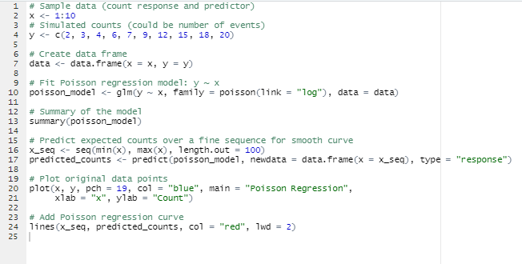
Output:
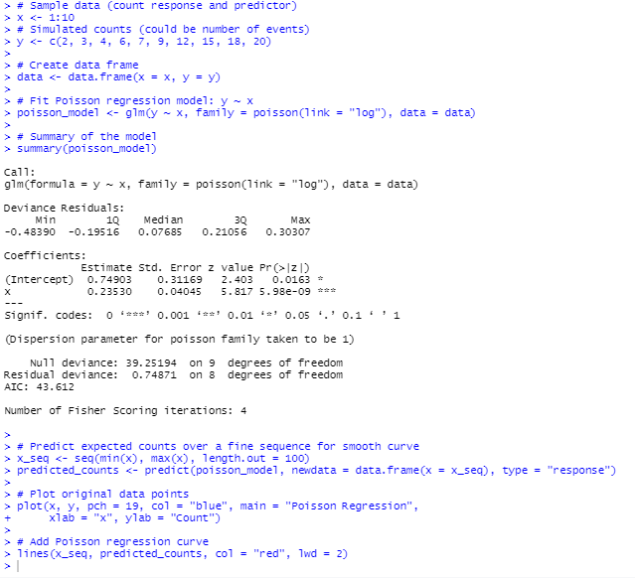
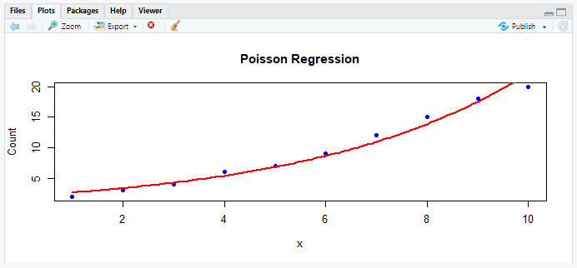
Explanation:
# Sample data (count response and predictor)
x <- 1:10
- Creates a numeric vector x containing integers from 1 to 10.
- This will be the predictor (independent variable).
# Simulated counts (could be number of events)
y <- c(2, 3, 4, 6, 7, 9, 12, 15, 18, 20)
- Creates a numeric vector y with count data (dependent variable).
- These could represent counts of events observed for each corresponding x.
# Create data frame
data <- data.frame(x = x, y = y)
- Combines vectors x and y into a data frame named data.
- Data frames are the standard format for modeling functions in R.
# Fit Poisson regression model: y ~ x
poisson_model <- glm(y ~ x, family = poisson(link = "log"), data = data)
- Fits a Poisson generalized linear model (GLM) predicting y using x.
- family = poisson(link = "log") specifies a Poisson distribution with a log link function, appropriate for count data.
- The fitted model is saved in the variable poisson_model.
# Summary of the model
summary(poisson_model)
- Displays a detailed summary of the Poisson regression model.
- Includes coefficient estimates, standard errors, z-values, p-values, and model fit statistics.
# Predict expected counts over a fine sequence for smooth curve
x_seq <- seq(min(x), max(x), length.out = 100)
- Creates a sequence x_seq of 100 evenly spaced values from the minimum to the maximum of x.
- Used to generate smooth predicted values for plotting the regression curve.
predicted_counts <- predict(poisson_model, newdata = data.frame(x = x_seq), type = "response")
- Uses the fitted model to predict expected counts (y) for each value in x_seq.
- type = "response" returns predictions on the original count scale (not on the log scale).
# Plot original data points
plot(x, y, pch = 19, col = "blue", main = "Poisson Regression",
xlab = "x", ylab = "Count")
- Creates a scatter plot of the original data points.
- pch = 19 sets the plotting character to solid circles.
- col = "blue" colors the points blue.
- main, xlab, and ylab set the plot title and axis labels.
# Add Poisson regression curve
lines(x_seq, predicted_counts, col = "red", lwd = 2)
- Adds a line showing the predicted Poisson regression curve.
- col = "red" colors the line red.
- lwd = 2 makes the line thicker for better visibility.

